# JS Advanced: Exam Preparation June 2019

Exam problems for the [“JavaScript Advanced” course @ SoftUni](https://softuni.bg/courses/js-advanced). Submit your solutions in the SoftUni Judge system at <https://judge.softuni.bg/Contests/Practice/Index/1664>.

# Problem 1. Form Acceptance

### Use the index.html and app.js files to solve this problem.

### Note: You can't and you have no permission to change directly the given html code (index.html file).

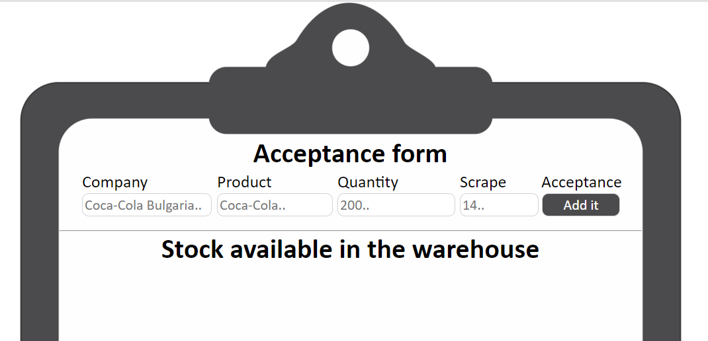

### Your Task

**Write the** **missing JavaScript code** to make the **Acceptance form** work as expected:

* When **all fields (company, product, quantity and scrape)** are **filled with correct input**
  + **Company** and **product** need to be **non**-**empty** **strings**
  + **Quantity** and **scrape** need to be **numbers**
* Upon pressing the **[Add it]** **button**, a new stock (**product**) should appear in the warehouse list,   
  on following format:  
  **[{companyName}] {productName} - {productQuantity} pieces {outOfStockButton}**
  + **Keep in mind that** you need to add the available quantity of the product that **is not scrape**. In these cases when the available product quantity is less or equal to zero (<= 0) you should **not add it** to the warehouse list
  + **If** one or all fields **are not filled,** you should do **nothing!**
* The input fields should be **reset** when the **[Add it]** **button** is **clicked**!
* When the **Out of stock** button is clicked, the current product (**the div element**) should **be removed** from the warehouse list

### Submission

Submit only your **acceptance()** function.

### Examples

**Before** we hit the **[Add it]** **button** with correct values for all the fields:

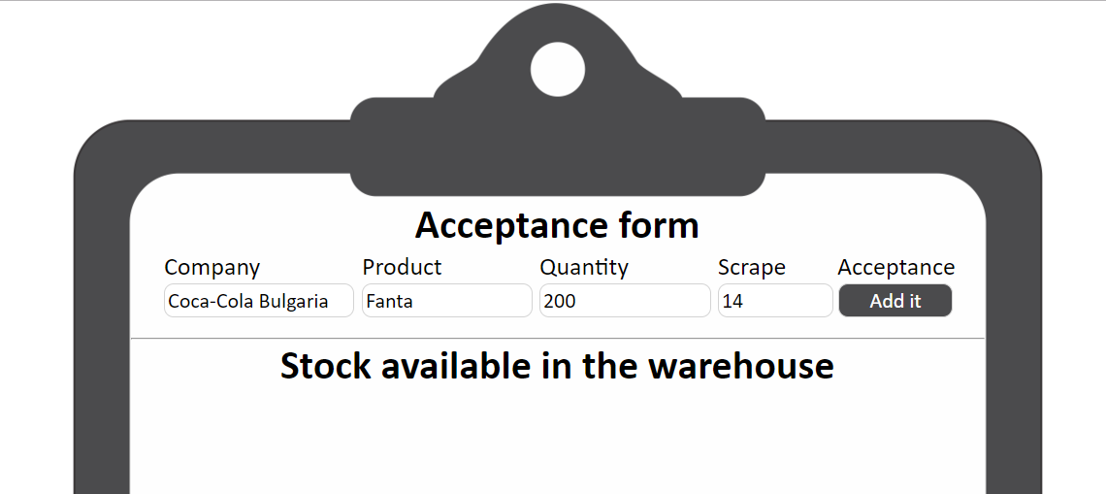

**After** we hit the **[Add it]** **button** 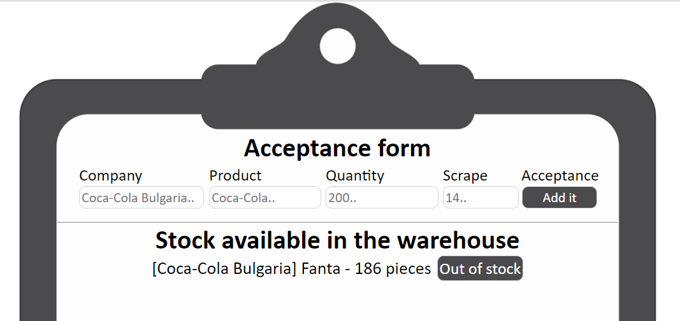

**Code structure after** we hit the **[Add it]** **button** and we added successfully a new product to the warehouse list:

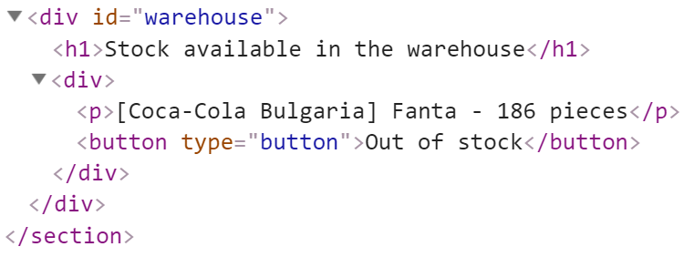

*GOOD LUCK… c(:*